**Assembling the system**

**I. Before starting**

***Know how to use a breadboard***

You should know how to use a solderless breadboard. It is simple and very useful. If you haven’t used a breadboard before, there are many nice tutorials available online, including this one: <https://learn.sparkfun.com/tutorials/how-to-use-a-breadboard>.

***Get your tools together***

You need two tools: a multimeter (to check resistances, the quality of connections, and voltages) and a wire stripper (if you are using the jumper wire kit mentioned in the parts list you don’t need this).

If you lack either of these tools, here are two suggestions:

Multimeter: <https://www.sparkfun.com/products/12966>

Wire stripper: <https://www.sparkfun.com/products/12630>

***Choose the resistor values***

In the manuscript, we gave resistor values suitable for our own patch clamp amplifier: Multiclamp 700B with a 500 MΩ feedback resistor and a current clamp gain of 10 (the latter two numbers are set in the Multiclamp Commander software). This amplifier with these settings amplifies the membrane potential $V_{m}$ by 100x at its scaled output (so that $V_{m}$ equal to -70 mV results in an output signal of -7.0 V) and uses a scaling of 400 pA/V to interpret signals at its command input (a change of -20 mV at the command input changes the injected current by -8 pA).

Other patch clamp amplifiers will have different gains/scalings. For example, an Axopatch 200B will have a gain of 10x from the output at its back panel (the output labeled “10 $V_{m}$”) and a scaling of 2000 pA/V when the gain knob labeled β is at the default position of 1. A Dagan BVC-700 will have a gain of 100x (typically) but its current clamp scaling will be 200 pA/V when one uses a 0.01 headstage. Other combinations are possible for other amplifiers with other settings.

The resistor values of the breadboard circuit for a given amplifier should be such as to make good use of the full dynamic range of the Teensy 3.6 ADC input (0-3.3V) and DAC output (0-3.3V). The relevant equations are given on pp. 1-2 of the supplementary document *Calibration_procedure*. In the tables below, we indicate some good resistor choices to maximize use of dynamic range for different combinations of $V_{m}$ gain and current scaling. In choosing resistors for the ADC input (resistors 1-6), we were somewhat conservative. It is important never to feed the Teensy ADC input a negative voltage or one larger than +3.3 V because that can damage it, and so we avoided getting too close to the lower and upper limits. In choosing resistors for the DAC output (resistors 7-10), we aimed for a precision of 0.5-1.0 pA. We also chose resistor values that could be created easily using individual resistors found in Sparkfun’s resistor kit (<https://www.sparkfun.com/products/10969>); every resistor value can be created with at most two resistors in series.

Resistor values for different ADC gains

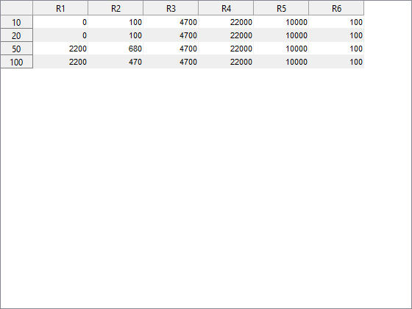

Resistor values for different DAC scalings

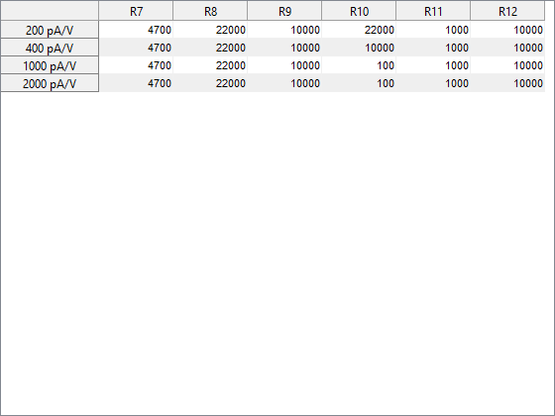

We will assemble the system compactly on a full-size breadboard, treating each of the five parts (main text Fig. 2) in turn.

**II. Power supply (Figure 2A)**

We begin with the power supply depicted (main text Fig. 2A). Power comes from a wall adapter connected through a barrel connector (Suppl. Fig. 1). (Note well: higher-quality images of the breadboard are available in the folder *Higher_quality_images* within this folder.)

The wall adapter we use has a positive barrel and a negative center. The barrel connector has three pins: the one at the front is positive, the one at the back is negative, and the middle one can be ignored. You should insert the barrel connector into the breadboard as in Suppl. Fig. 1 and then use one wire to connect the front pin to the positive (red) power rail and the back pin to the negative (blue) power rail, as in the picture.

***Be careful!*** Some wall adapters have the opposite polarity: the barrel is negative and the center is positive. If that is true of your adapter, you should reverse the connections to the power rails. In fact, to be careful, you should use your multimeter to measure the voltage difference between the red and blue rails when the wall adapter is plugged in. The multimeter probes most likely will not fit in the breadboard holes, but you can do this, as in the picture below, just by sticking wires with stripped ends into the board and pressing the probes against the ends.

**Supplementary Figure 1.** Getting power. An 18 V wall adapter with a barrel plug end (upper left). A barrel connector with a positive pin and a negative pin (lower left). The connector on the breadboard (right). The small red wire connects the front pin to the red power rail; the small black wire connects the back pin to the blue power rail. You can check that the voltage polarity is correct by sticking wires into the rails as shown and measuring the voltage difference with a multimeter. Red should be +18 V compared to blue. If the sign is reversed, connect the front pin to the blue power rail and the back pin to the red power rail.

Unplug the wall adapter. Never have the circuit connected to an electrical outlet while you’re assembling or changing it. Now we want to set up the rail splitter. This is the circuit:

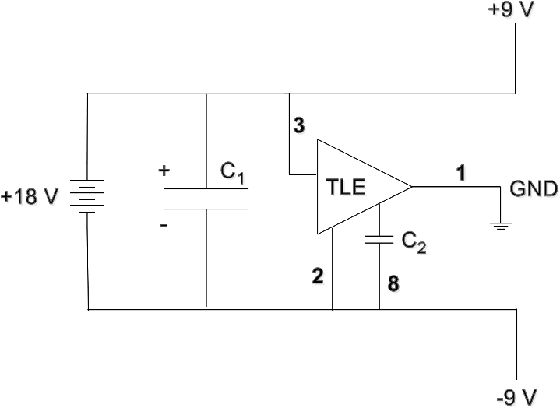

**Supplementary Figure 2.** Rail splitter circuit. The +18 V is the difference between the red and blue power rails at the bottom of the breadboard. *C1* is provided by electrolytic capacitors (200 μF) and *C2* is provided by a ceramic capacitor (1 μF). *TLE*  is the TLE 2426 IC chip; the dark numbers refer to the IC chip’s pins. The circuit creates a virtual ground that will be 9 V more negative than the (lower) red power rail and 9V more positive than the (lower) blue power rail. We will put this virtual ground at the (upper) blue power rail.

There should be a capacitance of 200 μF between the positive (red) and negative (blue) power rails. The Sparkfun capacitor kit does not include a 200 μF capacitor, but it does include many 100 μF capacitors. Capacitors in parallel sum together and so we can put two of them in parallel between the positive and negative rails. These are electrolytic capacitors and they have a polarity: the negative end is marked by a white stripe, a negative symbol, and shorter wire. Stick the positive ends in holes in the red rail and the negative ends in holes in the blue rail. It helps to trim the wires first so that they are the same length; you want both to fit securely in the breadboard holes.

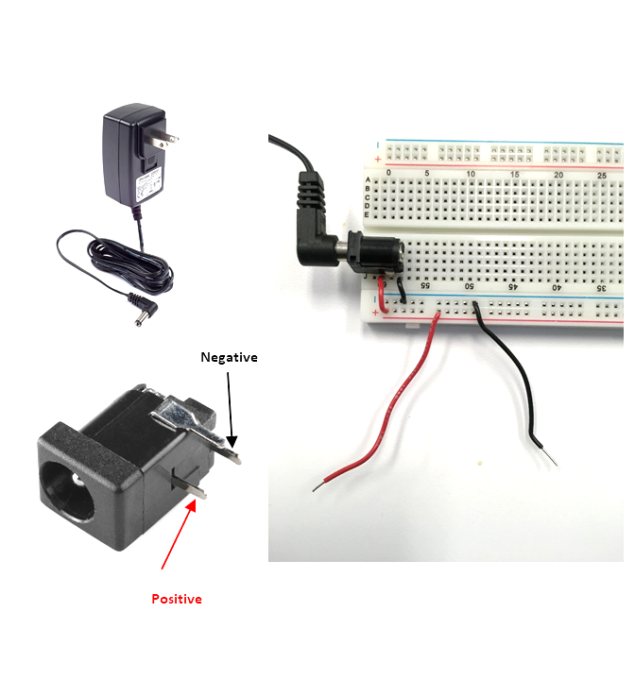

The pinout diagram of the TLE 2426 IC chip looks like this:

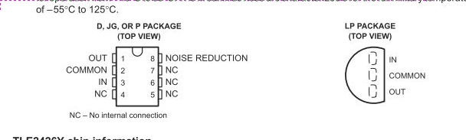**Supplementary Figure 3.** The pinout of the TLE 2426 IC chip. The pins labeled “NC” are not connected. The other pins go to virtual ground (1), negative power rail (2), positive power rail (3), via 1 μF to negative power rail (8).

Put it in the breadboard and make the requisite connections. The breadboard should now look something like this:

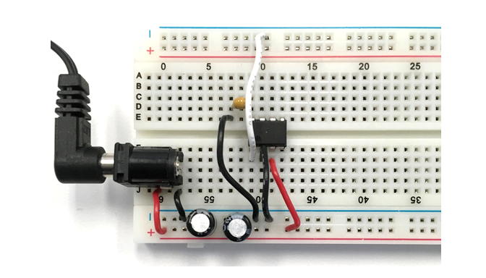**Supplementary Figure 4.** Power supply circuit on the breadboard. The yellow element is the 1 μF capacitor. Unlike the electrolytic capacitors, it does not have a polarity: just stick one end in the same row as pin 8 of the TLE 2426 and connect the other end (here via a black wire) to the negative (blue) power rail. The white wire connects pin 1 to the virtual ground rail (upper blue). The right-most black wire connects pin 2 to the negative power rail (lower blue). The right-most red wire connects pin 3 to the positive power rail (red).

**GND**

**-9 V**

**+9 V**

A few things to note about this figure. (1) You can see the white stripes of the two 100 μF capacitors along the negative power rail. (2) 1 μF capacitor is inserted in breadboard row 7 (connected by a black wire to the negative power rail) and breadboard row 9 (same row as pin 8 of the TLE 2426). (3) There is a circle in the lower left corner of the TLE 2426 chip (easier to see in the high-quality image). This is analogous to the semi-circle at the top of the pinout diagram in Suppl. Fig. 3. By spotting it, you can tell which pin is which. Given how the chip is oriented in this picture, the pins at the bottom are 1, 2, 3, and 4 (left to right) and those at the top are 8, 7, 6, and 5 (left to right).

You should plug in the wall adapter and use a multimeter to check that the positive power rail (lower red) is approximately 9 V more positive than the virtual ground (upper blue) and that the negative power rail (lower blue) is approximately -9 V more negative than the virtual ground. You will likely measure small differences from these numbers (0-2%) depending on your wall adapter; that is fine, as these differences can be corrected in software through the calibration procedure.

**III. Follower / voltage divider / differential amplifier (Figure 2B)**

The op-amp IC we use throughout is the LM358. Here is its pinout diagram:

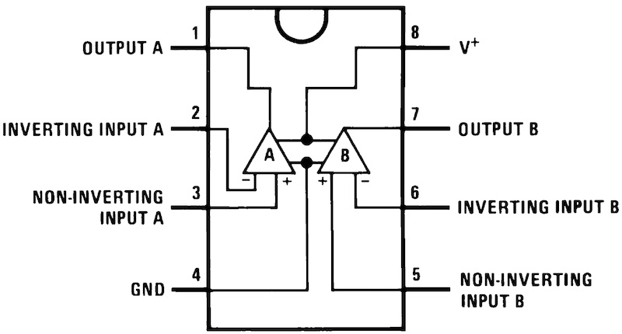

**Supplementary Figure 5.** LM358 integrated circuit chip. It contains two separate op-amps, which use common power supplies. In this diagram, pin 4 is labelled “GND” but really pin 4 is for the negative power supply. In some circuits, this will indeed be ground, but in our circuits it will be -9 V.

One nice thing about the LM358 is that it contains two separate op-amps, and so we can use one of these IC chips to create two separate circuits. In this section, we use a single LM358 to create both the follower and differential amplifier of main text Fig. 2B, along with a voltage divider.

First, let’s make the follower, as in the following figure.

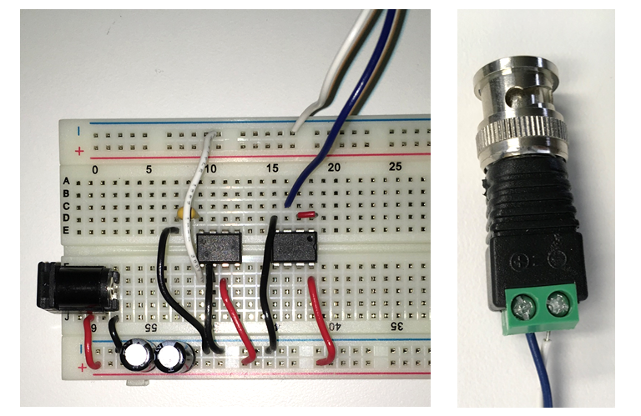

**Supplementary Figure 6.** Follower circuit added to the power supply of Suppl. Fig. 4. The dot at the upper right on the LM358 chip is analogous to the semi-circle of Suppl. Fig. 5 and helps orient us. The bottom pins are 5, 6, 7, and 8 (left to right), whereas the upper pins are 4, 3, 2, and 1 (left to right). The blue wire in row 16 (connected to pin 3) is the input signal from the patch clamp amplifier ($V_{IN}$). The amplifier’s reference is the white wire connected to the virtual ground (upper blue rail). The blue and white wires are connected to the BNC connector at right: blue goes to + and white goes to -.

In making the follower we used the op-amp in the upper half of the IC. We connected the pins 8 and 4 of the IC to the positive and negative power rails, respectively. We connected pins 1 and 2 (output and inverting input) via the little red wire (this just shorts them together). And we used a BNC connector (Suppl. Fig. 6 right) to connect them to the BNC output of the patch clamp amplifier. (Pictured is a male BNC connector. Similar female connectors are also available, if that would be more convenient.)

The output of the op-amp circuit is pin 1 (breadboard row 18 in the picture). Next, we will construct a voltage divider to scale the output down.

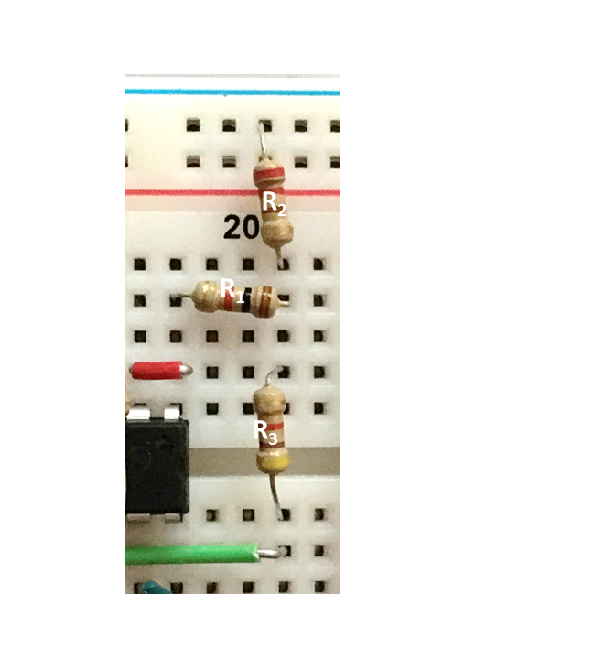

**Supplementary Figure 7.** Voltage divider. The output of the follower circuit (breadboard row 18) goes to one end of resistor R1 (using the nomenclature of main text Fig. 2B). This is in a voltage divider configuration with resistor R2. One end of R2 is connected to the virtual ground (upper blue rail). The other end, which is also connected to an end of R1 goes to resistor R3, which connects (via the green wire) to the non-inverting input of the other (lower) op-amp of the IC chip.

The green wire of Suppl. Fig. 7 should go to the non-inverting input of the op-amp in the lower half of the LM358 chip (pin 5 of pinout diagram of Suppl. Fig. 5). This pin is also connected to the positive (+9 V) power rail via a resistor (R4 of main text Fig. 2B). Completing the differential amplifier by adding resistors R5 and R6, we have Suppl. Fig. 8.

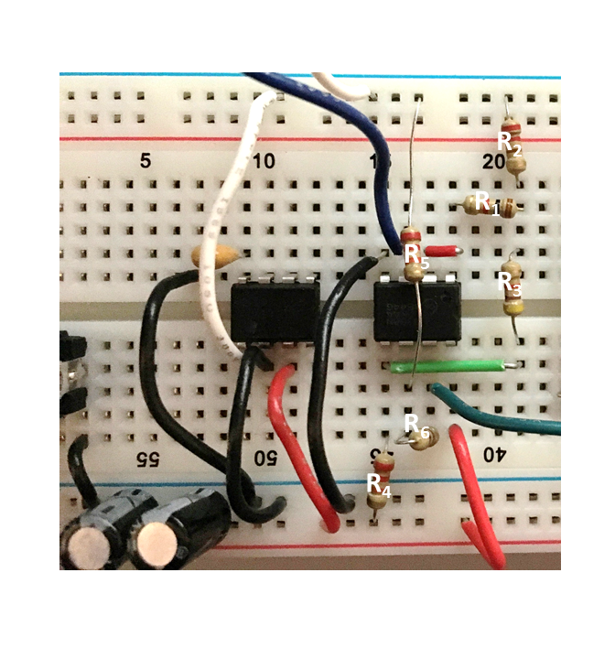

**Supplementary Figure 8.** The circuit now includes a power supply, a follower, a voltage divider, and a differential amplifier (main text Fig. 2A and 2B). The three new resistors are connected as follows: R4 goes from pin 5 of the LM358 (non-inverting input B) to the positive power rail (red); R5 goes from pin 6 of the LM358 (inverting input B) to the virtual ground; and R6 connects pin 6 to pin 7 (output B). The dark green wire also coming from pin 7 (breadboard row 43) goes to the ADC input of the Teensy microcontroller.

The output of this circuit ($V_{OUT}$, the dark green wire exiting stage right in the picture) should be related to the input ($V_{IN}$, dark blue wire of breadboard row 16) like this:

$$V_{OUT}=(1+ \frac{R_{6}}{R_{5}})\left[\frac{R_{4}R_{2}}{\left(R_{3}+R_{4}\right)\left(R_{1}+R_{2}\right)}V_{IN}+9\frac{R_{3}}{\left(R_{3}+R_{4}\right)}\right]$$

It would be useful to check that this relationship is (approximately) true. If it is not, then that is a strong indication that you should recheck all the connections using your multimeter – especially make sure that all the resistors and wires are well seated in the breadboard holes. This is especially a concern with the resistors, as their wires are thin and a bit too prone to bending in odd ways.

If you would like to check, you might wonder where to get $V_{IN}$. A simple solution is to use the Teensy 3.6 itself. When the Teensy is connected to the host computer via the USB port, it draws power from the port and two of its pins emit 3.3 V (see diagram below). You can replace the blue wire (breadboard row 16, going to pin 3 of the LM358) with this 3.3 V while using a multimeter to measure the voltage of the dark green wire (referenced against the virtual ground).

**IV. Teensy 3.6 connections (Figure 2C)**

Here is the pinout diagram of the Teensy 3.6 microcontroller.

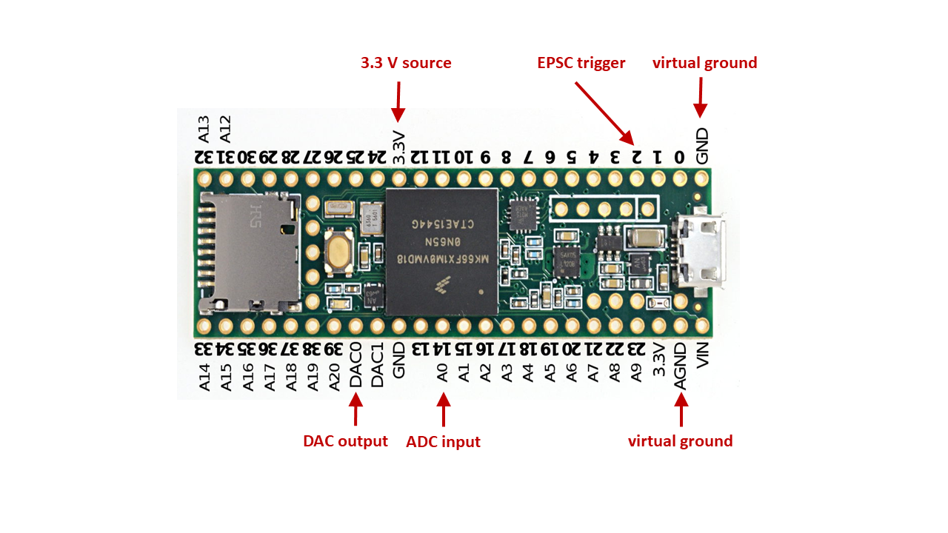

**Supplementary Figure 9.** Pinout diagram of the Teensy 3.6. Shown are the connections the Teensy makes with other parts of the system: the output of Suppl. Fig. 8 ($V_{OUT}$) goes to A0 (ADC input); the virtual ground (upper blue rail) is connected to both the GND pin at upper right and the AGND pin at lower right; the Teensy output (DAC output) will go to the differential amplifier we will construct in Part V); and the 3.3 V source is indicated for those who wish to check their circuits.

And here is how the connections look on a breadboard.

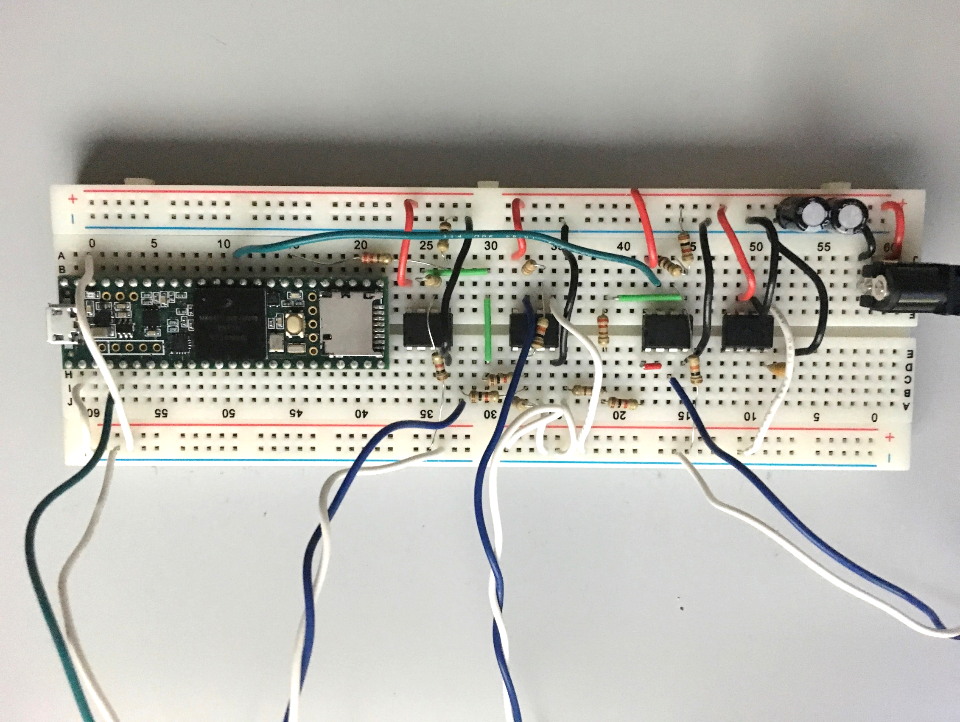

**Supplementary Figure 10.** Teensy connections. The dark green wire at upper right transmits a TTL trigger for EPSCs. It connects pin 2 of the Teensy (breadboard row 58 in the picture) with the positive terminal of a BNC connector. The connector’s negative terminal is attached to a white wire that connects to the virtual ground (upper blue rail). The output of the Teensy microcontroller (DAC0, breadboard row 15 in the picture) goes via a resistor (R7, in the nomenclature of main text Fig. 2) to the upcoming differential amplifier (main text Fig. 2D).

**V. Differential amplifier (Figure 2D)**

The output of the Teensy microcontroller (DAC0 in Suppl. Fig. 10, breadboard row 15 in Suppl. Fig. 10) goes to the differential amplifier of main text Fig. 2B via a resistor R7.

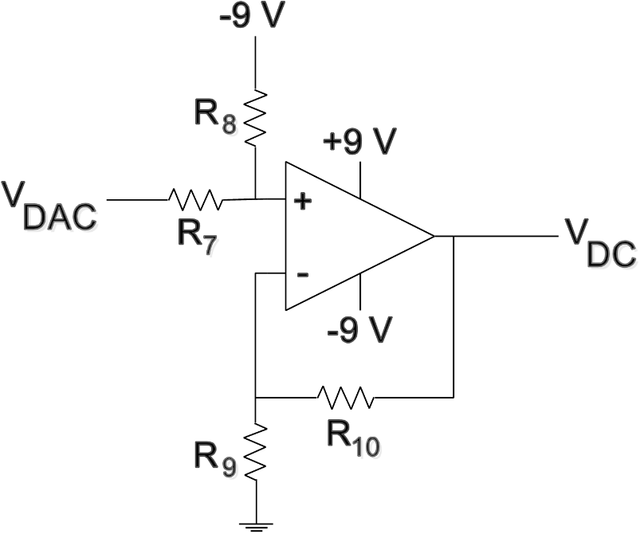**Supplementary Figure 11.** The output (DAC0) of the Teensy microcontroller is VDAC. We connect it to a resistor that goes to the non-inverting input of the op-amp.

Again, we use a LM358 IC chip to provide an op-amp (Suppl. Fig. 5). But here we only use the lower op-amp.

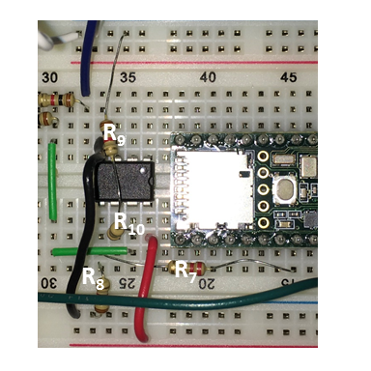

**Supplementary Figure 12.** The LM358 pinout diagram was given in Suppl. Fig. 5. The dot and semi-circle can be seen on the right side of the chip – so the lower pins are 5, 6, 7, and 8 (left to right), and the upper pins are 4, 3, 2, and 1 (left to right). The output of the lower op-amp is pin 7 (breadboard row 25.) The bright green wires connect it to breadboard row 30 of the upper half.

**V. Summing (Figure 2E)**

The fifth and last part of the system is to sum the dynamic clamp voltage command and the current clamp voltage command (main text Fig. 2E). This involves two inverting amplifiers in series.

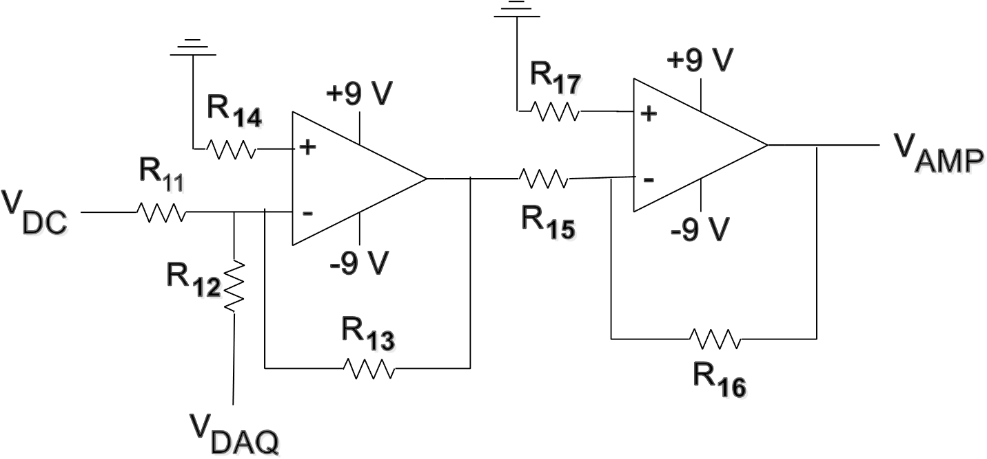

**Supplementary Figure 13.** Two summing circuits in series. VDC is the output of the differential amplifier of Suppl. Fig. 12; VDAQ is the output of the DAQ system (current clamp command).

The LM358 contains two op-amps and so we can construct both inverting amplifiers using just one. This is what the breadboard portion looks like:

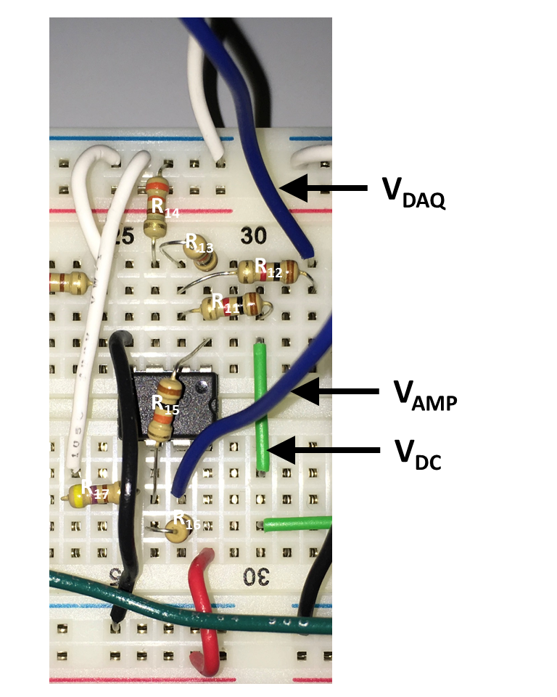**Supplementary Figure 14.** Summing circuit. The op-amp of the upper half of the IC sums and inverts signals from the dynamic clamp system (VDC, green wire ascending to breadboard row 30) and the current clamp system (VDAQ, dark blue wire going to breadboard row 32). The op-amp of the lower half inverts the signal back. Its output, which goes to the patch clamp amplifier, is carried by the dark blue wire called VAMP. The resistors are as defined in main text Fig. 2E.

**VI. All together**

This is what the complete breadboard circuit looks like.

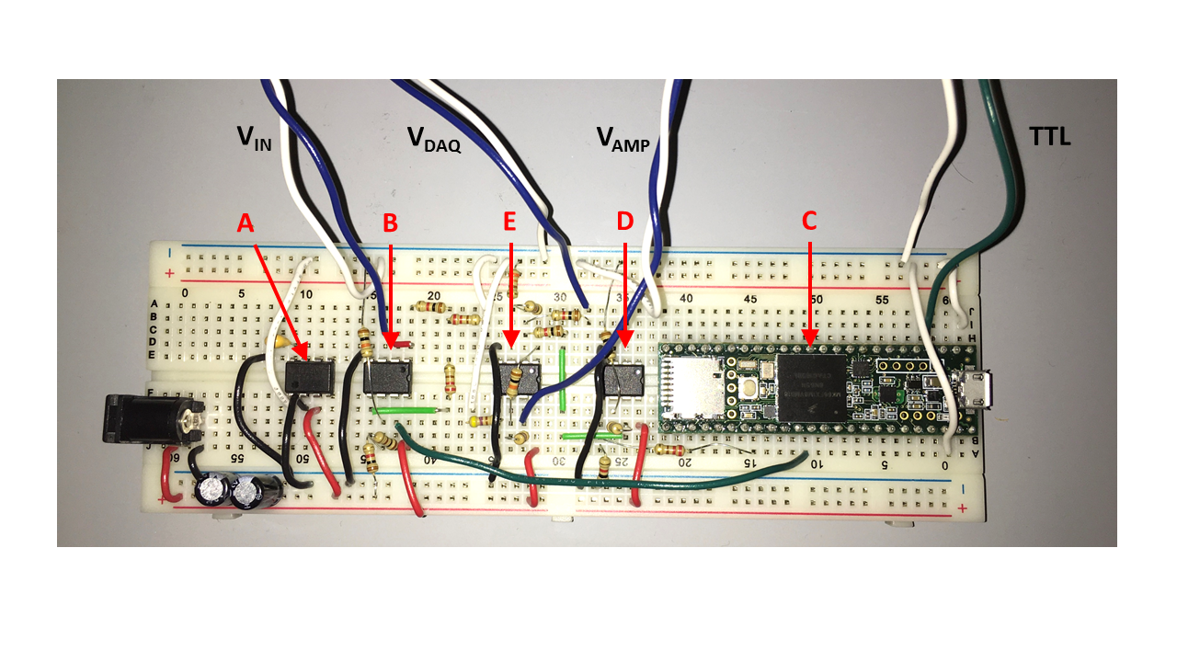

**Supplementary Figure 15.** The voltages (VIN, VDAQ, VAMP, and TTL) are the same as those of main text Fig. 2. The letters (A, B, C, D, E) refer to the five panels of main text Fig 2.